DBMS PROJECT
SPORTS SHOP MANAGEMENT SYSTEM

CONTENTS

S NO. | PAGE NO. | TOPIC
I | 3 | AIM
II | 3 | OBJECTIVE
III | 3 | TOOLS USED
IV | 4 | E-R DIAGRAM
V | 5 | WIREFRAME
VI | 6 | TABLES AND DATA
VII | 8 | COMPONENTS
VIII | 21 | CODE
IX | 29 | CONCLUSION
X | 29 | REFERANCE

SPORTS STORE MANAGEMENT SYSTEM

AIM
The project aims to make the process of managing a store easy.

OBJECTIVE
1. A separate user interface designed for customer and employee.
2. Easy updation of employee details
2. Special privilege for the manager for adding an employee is done
3. Efficient stock maintenances
4 .Automatic updation of stock details after each billing.
5 .Customized view of goods gives the customer a clear goal.

TOOLS USED
1. Microsoft Power Point Presentation V.2016
2. VB Forms
3. Oracle DBMS V.12C
4. oracle in OraDB12Home 1 64 bit ODBC Data Source Provider for DSN

E-R DIAGRAM

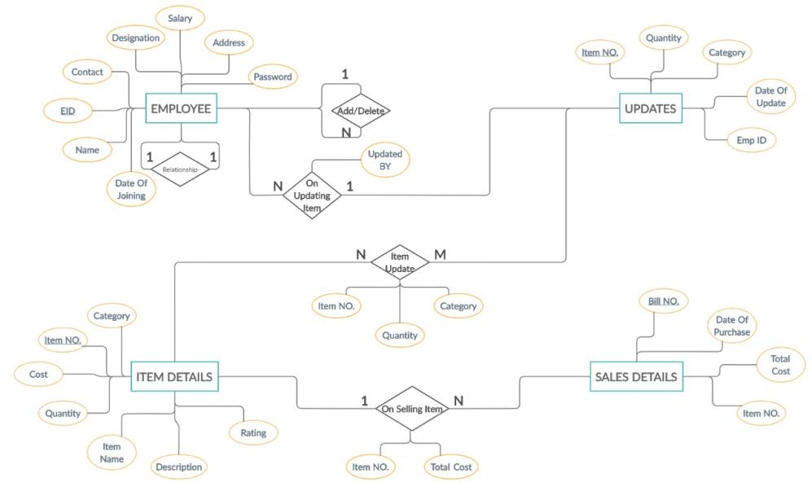

PROJECT WIREFRAME

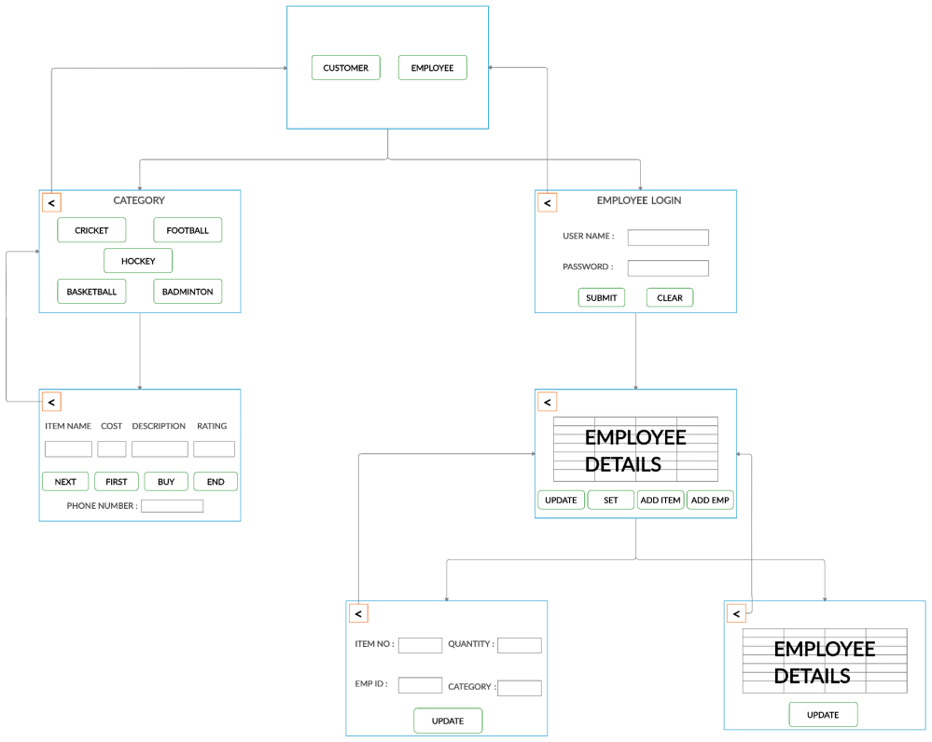

TABLES AND DATA

1. ITEMS DETAILS TABLE (IDT)
VIEW FOR FOOTBALL
VIEW FOR CRICKET
VIEW FOR BADMINTON
VIEW FOR BASKETBALL
VIEW FOR HOCKEY
Item-no | Cost | Quantity | ItemName | Description | Rating | Category
1000 | 200 | 15 | Cork Ball | Circumference 9.1 inches | 4/5 | Cricket
1001 | 3000 | 12 | Mangoose Bat | Willow Tree wood bat | 5/5 | Cricket
1002 | 1500 | 25 | Stump | Birch Wood stump | 3.5/5 | Cricket
1003 | 200 | 23 | Bails | Wood Crosspiece | 4/5 | Cricket
1004 | 3500 | 10 | Boundary rope | White,5 cm thick | 4.5/5 | Cricket
2000 | 5500 | 20 | Football | Lightweight | 5/5 | Football
2001 | 10000 | 35 | Stud Shoe | Lightweight | 4.5/5 | Football
2002 | 200 | 35 | Socks | Woollen, Thick | 4.5/5 | Football
2003 | 500 | 35 | Gloves | Rubber, Protective | 5/5 | Football
2004 | 250 | 35 | Guard | Hard Plastic | 4.5/5 | Football
3000 | 4000 | 20 | Hockey Bat | Hard Wood | 4/5 | Hockey
3001 | 1000 | 25 | Helmet | Hard Plastic | 4.5/5 | Hockey
3002 | 750 | 20 | Mouth Guard | Silicone, Soft | 3/5 | Hockey
3003 | 250 | 30 | Hockey Puck | 3 inch Diameter | 4.5/5 | Hockey
3004 | 5000 | 15 | Guard Set | Full guard set with gloves | 5/5 | Hockey
4000 | 2000 | 20 | Basketball | Medium Size | 4.5/5 | Basketball
4001 | 2000 | 20 | Basketball | Large Size | 5/5 | Basketball
4002 | 750 | 25 | Mouth guard | Hard plastic Guard | 4/5 | Basketball
4003 | 5000 | 10 | Hoop | 10ft high,18 inch diameter | 5/5 | Basketball
4004 | 450 | 35 | Jersey | Nylon shirt | 3.5/5 | Basketball
5000 | 2500 | 40 | Racquet | Nylon Braided | 4.5/5 | Badminton
5001 | 750 | 30 | Shuttlecock | Set of 7 | 5/5 | Badminton
5002 | 3000 | 25 | Shoes | Lightweight | 5/5 | Badminton
5003 | 2500 | 10 | Net | Nylon,6.1 mm wide | 4.5/5 | Badminton
5004 | 2500 | 5 | Shuttle launcher | Speed Modifiable | 5/5 | Badminton
2. EMPLOYEE TABLE (ET)
Name | EMP Id | Salary | Contact | Desig | Address | DOJ | Password
Zeus | 100 | 80000 | 9999 | President | Cavour | 1-Jan-18 | meow
Hera | 101 | 75000 | 9997 | Vice President | Della | 2-Feb-18 | becca
Poseidon | 333 | 70000 | 8979 | Senior Manager | Del corso | 3-Mar-18 | lame
Demeter | 103 | 65000 | 8777 | Manager | Fari Imperviali | 4-Apr-18 | bees
Athena | 104 | 60000 | 0007 | Interior  Manager | Criulia | 5-May-18 | twix
Apollo | 105 | 55000 | 6969 | Sales Analyst | Margutta | 6-Jun-18 | mars
Artemis | 106 | 50000 | 4020 | Marketing Analyst | Nazionale | 7-Jul-18 | echo
Ares | 107 | 47000 | 9777 | Store Manager | Sacra | 8-Aug-18 | pencil
Hestia | 108 | 40000 | 2162 | Store employee | Centro | 9-Sep-18 | rocket
Janus | 109 | 40000 | 6921 | Store employee | Starvice | 10-Oct-18 | sorry

3. SALES DETAILS TABLE (SDT)
Bill No. / Phone No. | Date of purchase | Cost | Item No.
TO BE FILLED AS UPDATE TAKES PLACE

4. UPDATE TABLE ()
Item No. | Quantity | Category | Date Of Update | Updated By
TO BE FILLED AS UPDATE TAKES PLACE

COMPONENTS

Start-up Page:
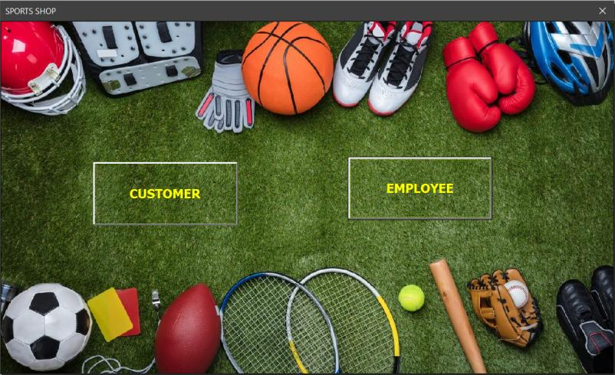
Elements:
1. frm_start_page (form for the content)
2. cmd_customer (connects to the page viewed by the customer)
3. cmd_employee (connects to the page viewed by the employee)

Categories Page (Customer)
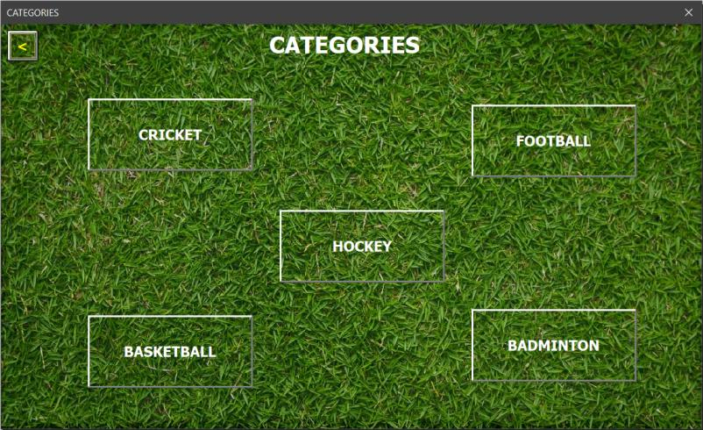
Elements:
1. frm_category (form for the content)
2. cmd_back_category (connects the contents page to the main page)
3. cmd_cricket (connects to the items page for cricket)
4. cmd_football (connects to the items page for football)
5. cmd_hockey (connects to the items page for hockey)
6. cmd_basketball (connects to the items page for basketball)
7. cmd_badminton (connects to the items page for badminton)
8. frm_items_list (form for displaying the items list as required)

Item List Page Structure (Customer)
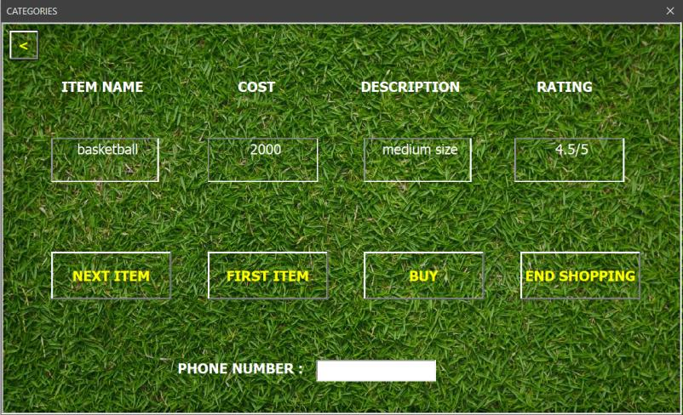
Elements:
1. frm_items_list (form for the content)
2. cmd_back_items (connects items list page to categories page)
3. cmd_next (displays the next item)
4. cmd_first (displays the first item)
5. cmd_buy (button to buy the item currently displayed)
6. cmd_end (button to end the shopping)
7. txt_item_name (container to hold the item name)
8. txt_cost (container to hold the cost)
9. txt_description (container to hold the description)
10. txt_rating (container to hold the rating)
11. txt_phno (container to get the phone number of the customer)

Action when a customer presses “BUY” without providing the phone number
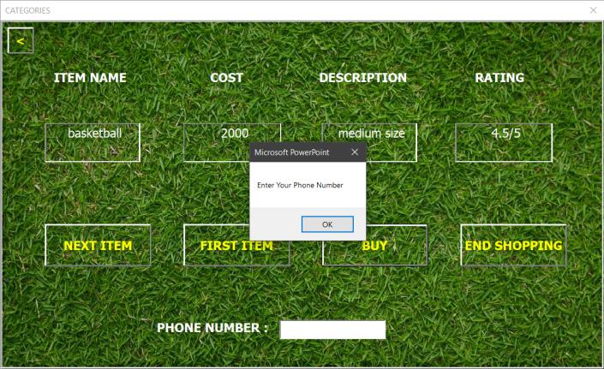

Action when “BUY” is pressed after the phone number is provided
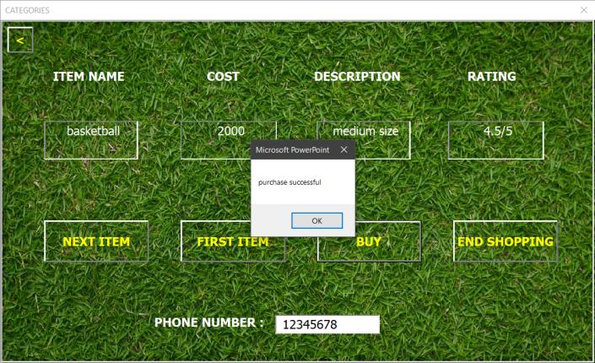

Update in the SDT table after an item is bought (bill no is the phone number provided)
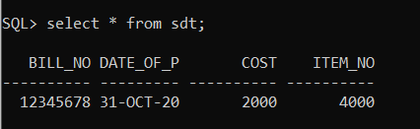
Update in the quantity after the purchase has been done
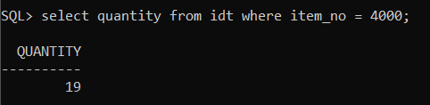

Action after all the items has been traversed
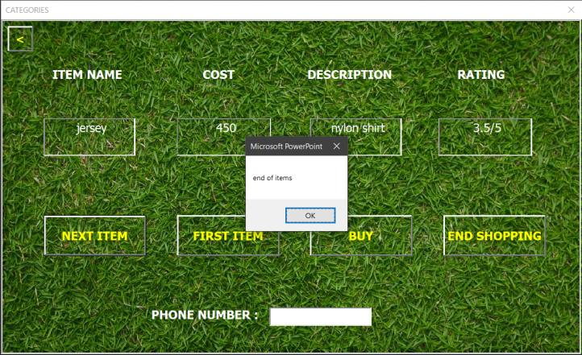

Action after end shopping is pressed
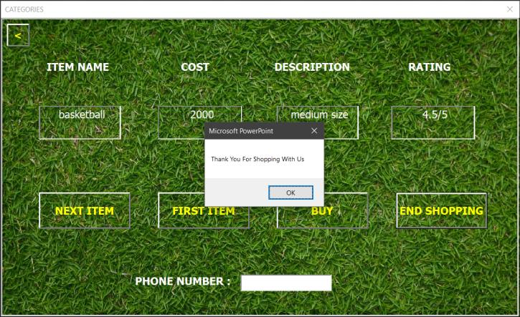

Employee Login Page (Employee)
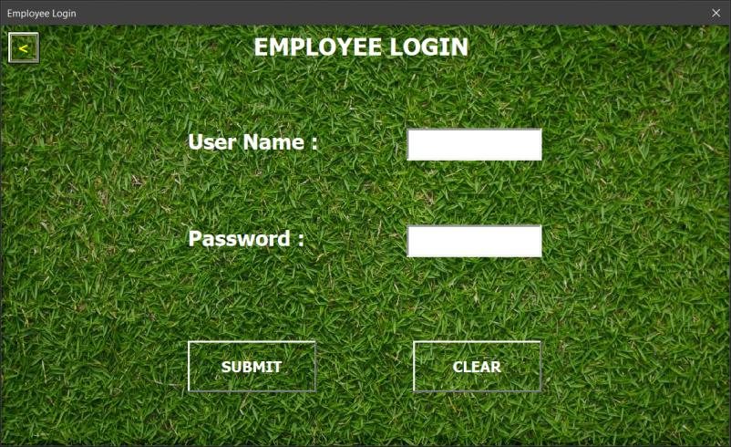

Elements
1. frm_employee_page (form for the contents of employee login page)
2. frm_normal_employee (frame to hold the contents after login)
3. cmd_back_emp (connects employee login page to the start page)
4. cmd_submit (connects the employee details frame and login page)
5. cmd_clear (clears the fields that are required to be filled during login)
6. txt_pwd (container to hold the password given by the login recipient)
7. txt_user_name (container to hold the username given by the login recipient)

Action when a non-registered user tries to login
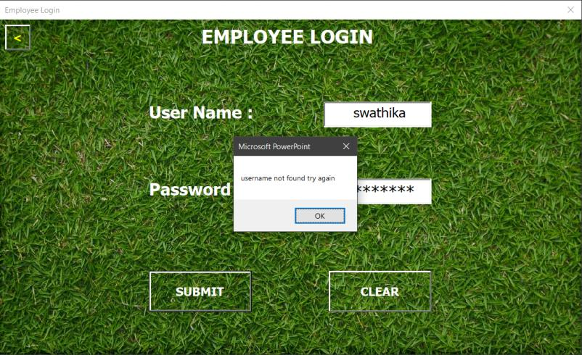

Employee Details Page (After Initial Login)
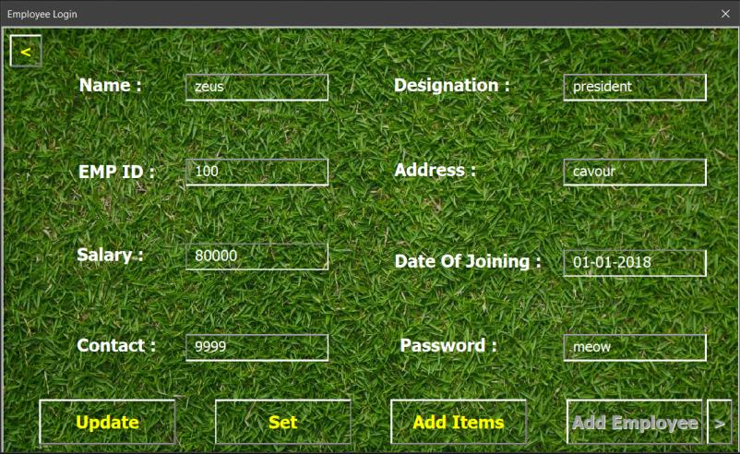
TO NOTICE: Add Employee button is disabled for all the employees except the manager

Elements:
1. frm_normal_employee (frame for the content)
2. cmd_back_normal_employee (connects details page to login page)
3. cmd_update (button to update details of the existing login recipient)
4. cmd_set (button to set the updated values)
5. cmd_add_items (connects the details page to the item updates frame)
6. cmd_add_employee (button to add new employees)
7. cmd_emp_update (button to set the new values of the new employees)
8. txt_name (content box to view/edit/add the name)
9. txt_emp_id (content box to view/add the emp_id)
10. txt_salary (content box to view/add the salary)
11. txt_contact (content box to view/edit/add the contact)
12. txt_designation (content box to view/add the designation)
13. txt_address (content box to view/edit/add the address)
14. txt_doj (content box to view/add the date of joining)
15. txt_password (content box to view/edit/add the password)
16. frm_add_items (frame when add items is pressed)

Action when “Update” is pressed
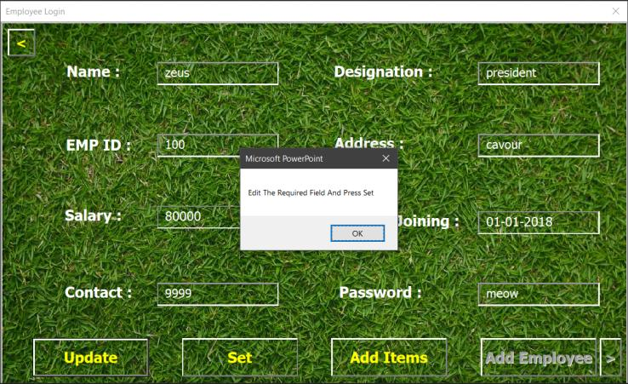

Action when set is pressed
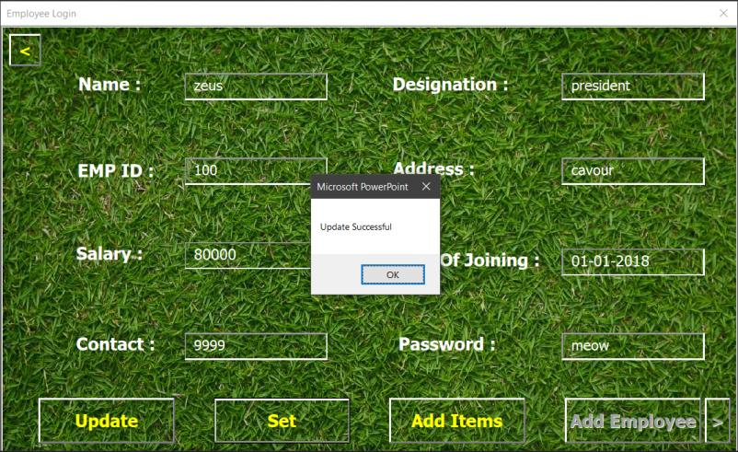

Action when the manager has logged in
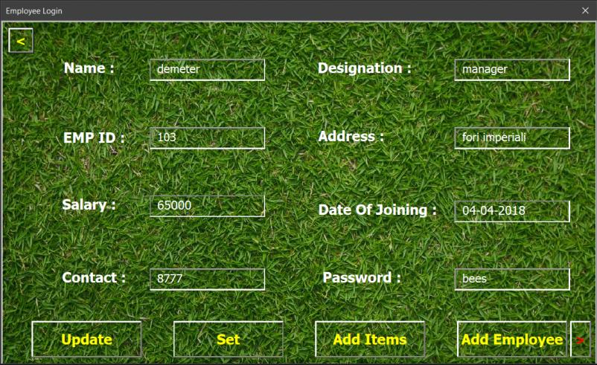
TO NOTICE: Add employee has been emabled as soon as the manager has logged in

Action when “Add Employee” is pressed
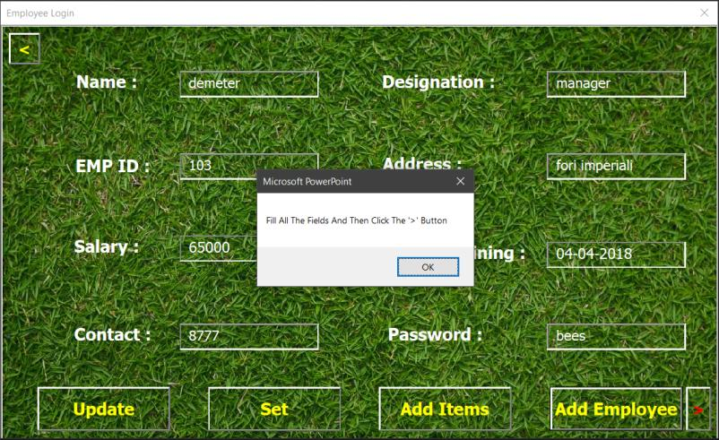

Filling up of new employee details
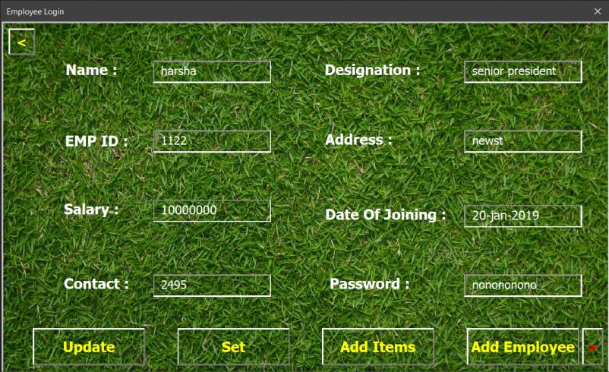

Action after new employee has been added
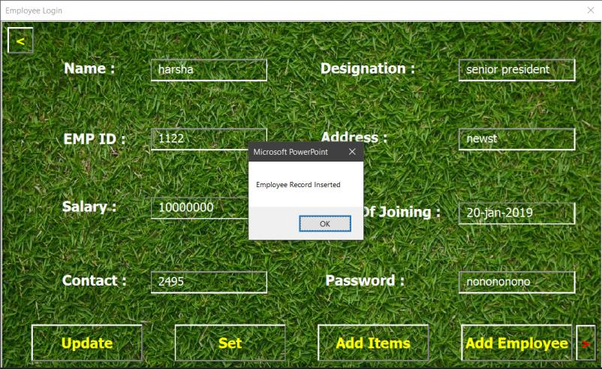

Update in ET after new employee has been added
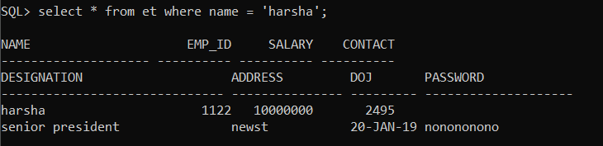

Action after “Add Item” has been pressed
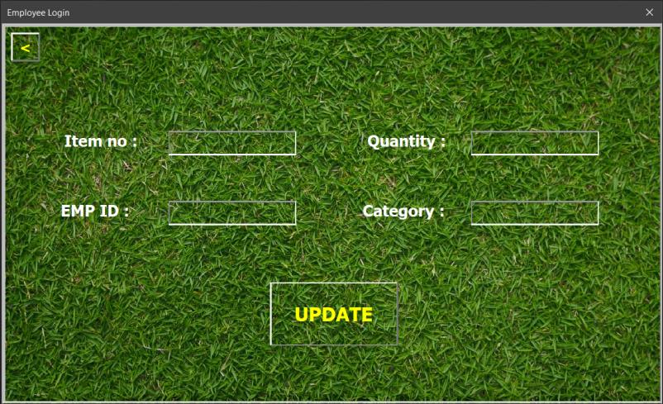

Filling up of new item details
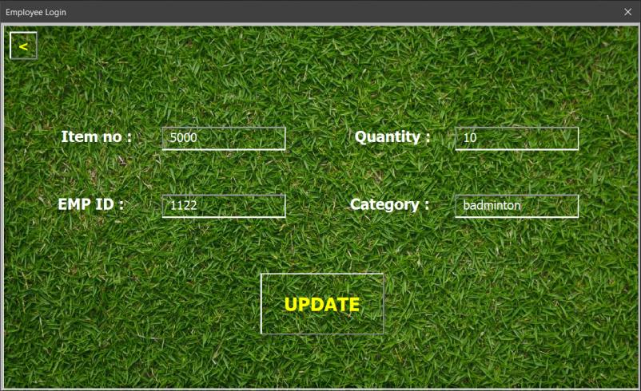

Action after item has been added
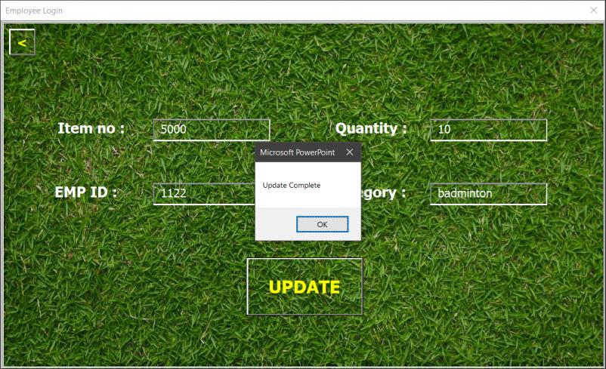

Update in UT after item has been added
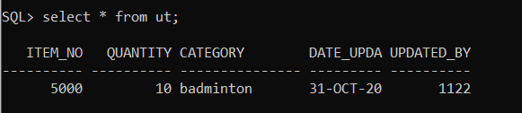

Update in IDT after item has been added
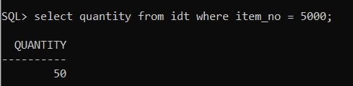

CODE

Start-up Page:

Private Sub cmd_customer_Click()
frm_start_page.Hide
frm_category.Show
End Sub
---------------------------------------------------------------------------------------------------------
Private Sub cmd_employee_Click()
frm_start_page.Hide
frm_employee_page.Show
End Sub
________________________________________________________________________________________________________________________________

Employee Page:

Dim pwd As String
Dim db As ADODB.Connection
Dim rec As ADODB.Recordset
Dim update As ADODB.Recordset
---------------------------------------------------------------------------------------------------------
Private Sub cmd_add_employee_Click()
MsgBox "Fill All The Fields And Then Click The '>' Button"
txt_name.Text = ""
txt_emp_id.Text = ""
txt_salary.Text = ""
txt_contact.Text = ""
txt_designation.Text = ""
txt_address.Text = ""
txt_doj.Text = ""
txt_password.Text = ""
txt_name.Locked = False
txt_emp_id.Locked = False
txt_salary.Locked = False
txt_contact.Locked = False
txt_designation.Locked = False
txt_address.Locked = False
txt_doj.Locked = False
txt_password.Locked = False
End Sub
---------------------------------------------------------------------------------------------------------
Private Sub cmd_add_items_Click()
frm_add_items.Visible = True
End Sub
---------------------------------------------------------------------------------------------------------
Private Sub cmd_back_add_item_Click()
frm_add_items.Visible = False
txt_item_no.Text = ""
txt_emp_no.Text = ""
txt_category.Text = ""
txt_quantity.Text = ""
End Sub
---------------------------------------------------------------------------------------------------------
Private Sub cmd_back_emp_Click()
frm_employee_page.Hide
frm_start_page.Show
End Sub
---------------------------------------------------------------------------------------------------------
Private Sub cmd_back_normal_employee_Click()
txt_name.Locked = True
txt_emp_id.Locked = True
txt_salary.Locked = True
txt_contact.Locked = True
txt_designation.Locked = True
txt_address.Locked = True
txt_doj.Locked = True
txt_password.Locked = True
frm_normal_employee.Visible = False
txt_user_name.Text = ""
txt_pwd.Text = ""
End Sub
---------------------------------------------------------------------------------------------------------
Private Sub cmd_clear_Click()
txt_user_name.Text = ""
txt_pwd.Text = ""
End Sub
---------------------------------------------------------------------------------------------------------
Private Sub cmd_emp_update_Click()
If txt_password.Text = "" Then
MsgBox "Fill All The Contents And Press This Button"
Else
Set db = New ADODB.Connection
Set rec = New ADODB.Recordset
db.Open ("DSN=sport;USER ID = SYSTEM; Password = SYSTEM")
rec.Open "insert into et values ('" & txt_name.Text & "', " & txt_emp_id.Text & ", " & txt_salary.Text & ", " & txt_contact.Text & ", '" & txt_designation.Text & "', '" & txt_address.Text & "', '" & txt_doj.Text & "', '" & txt_password.Text & "')", db, adOpenDynamic, adLockBatchOptimistic
MsgBox "Employee Record Inserted"
End If
txt_name.Text = ""
txt_emp_id.Text = ""
txt_salary.Text = ""
txt_contact.Text = ""
txt_designation.Text = ""
txt_address.Text = ""
txt_doj.Text = ""
txt_password.Text = ""
End Sub
---------------------------------------------------------------------------------------------------------
Private Sub cmd_set_Click()
If txt_name.Locked = True Then
MsgBox "Press Update And Then Press Set"
Else
Set db = New ADODB.Connection
Set rec = New ADODB.Recordset
db.Open ("DSN=sport;USER ID = SYSTEM; Password = SYSTEM")
rec.Open "update et set name = '" & txt_name.Text & "', contact = '" & txt_contact.Text & "', address = '" & txt_address.Text & "', password = '" & txt_password.Text & "' where emp_id = '" & txt_emp_id.Text & "'", db, adOpenDynamic, adLockBatchOptimistic
MsgBox "Update Successful"
End If
End Sub
---------------------------------------------------------------------------------------------------------
Private Sub cmd_submit_Click()
Set db = New ADODB.Connection
Set rec = New ADODB.Recordset
db.Open ("DSN=sport;USER ID = SYSTEM; Password = SYSTEM")
rec.Open "select * from et where name = '" & txt_user_name & "'", db, adOpenDynamic, adLockBatchOptimistic
If rec.EOF = False Then
If rec("password") = pwd Then
If rec("designation") = "manager" Then
frm_normal_employee.Visible = True
txt_name.Text = rec("name")
txt_emp_id.Text = rec("emp_id")
txt_salary.Text = rec("salary")
txt_contact.Text = rec("contact")
txt_designation.Text = rec("designation")
txt_address.Text = rec("address")
txt_doj.Text = rec("doj")
txt_password.Text = rec("password")
cmd_add_employee.Enabled = True
cmd_add_employee.Locked = False
cmd_emp_update.Enabled = True
cmd_emp_update.Locked = False
Else
frm_normal_employee.Visible = True
txt_name.Text = rec("name")
txt_emp_id.Text = rec("emp_id")
txt_salary.Text = rec("salary")
txt_contact.Text = rec("contact")
txt_designation.Text = rec("designation")
txt_address.Text = rec("address")
txt_doj.Text = rec("doj")
txt_password.Text = rec("password")
cmd_add_employee. Enabled = False
cmd_add_employee. Locked = True
cmd_emp_update. Enabled = False
cmd_emp_update.Locked = True
End If
Else
MsgBox "Password Incorrect Try Again"
txt_pwd.Text = ""
End If
Else
MsgBox "username not found try again"
txt_pwd.Text = ""
txt_user_name.Text = ""
End If
End Sub
---------------------------------------------------------------------------------------------------------
Private Sub cmd_update_Click()
txt_name.Locked = False
txt_contact.Locked = False
txt_address.Locked = False
txt_password.Locked = False
MsgBox "Edit The Required Field And Press Set"
End Sub
---------------------------------------------------------------------------------------------------------
Private Sub cmd_update_items_Click()
Set db = New ADODB.Connection
Set rec = New ADODB.Recordset
Set update = New ADODB.Recordset
db.Open ("DSN=sport;USER ID = SYSTEM; Password = SYSTEM")
rec.Open "update idt set quantity = quantity + " & txt_quantity.Text & " where item_no = " & txt_item_no.Text & "", db, adOpenDynamic, adLockBatchOptimistic
update.Open "insert into ut values (" & txt_item_no.Text & ", " & txt_quantity.Text & ", '" & txt_category.Text & "', sysdate, " & txt_emp_no.Text & ")", db, adOpenDynamic, adLockBatchOptimistic
MsgBox "Update Complete"
txt_item_no.Text = ""
txt_quantity.Text = ""
txt_emp_no.Text = ""
txt_category.Text = ""
End Sub
---------------------------------------------------------------------------------------------------------
Private Sub txt_pwd_AfterUpdate()
pwd = txt_pwd.Text
End Sub
---------------------------------------------------------------------------------------------------------
Private Sub UserForm_Activate()
frm_normal_employee.Visible = False
frm_add_items.Visible = False
End Sub
________________________________________________________________________________________________________________________________

Customer Page:

Dim db As ADODB.Connection
Dim rec As ADODB.Recordset
Dim rec_update As ADODB.Recordset
Dim rec_sdt As ADODB.Recordset
Dim qua As Integer
---------------------------------------------------------------------------------------------------------
Private Sub cmd_back_category_Click()
frm_category.Hide
frm_start_page.Show
End Sub
---------------------------------------------------------------------------------------------------------
Private Sub cmd_back_items_Click()
frm_items_list.Visible = False
End Sub
---------------------------------------------------------------------------------------------------------
Private Sub cmd_badminton_Click()
frm_items_list.Visible = True
Set db = New ADODB.Connection
Set rec = New ADODB.Recordset
db.Open ("DSN=sport;USER ID = SYSTEM; Password = SYSTEM")
rec.Open "select * from idt_badminton", db, adOpenDynamic, adLockBatchOptimistic
rec.MoveFirst
txt_item_name.Text = rec("item_name")
txt_cost.Text = rec("cost")
txt_description.Text = rec("description")
txt_rating.Text = rec("rating")
End Sub
---------------------------------------------------------------------------------------------------------
Private Sub cmd_basketball_Click()
frm_items_list.Visible = True
Set db = New ADODB.Connection
Set rec = New ADODB.Recordset
db.Open ("DSN=sport;USER ID = SYSTEM; Password = SYSTEM")
rec.Open "select * from idt_basketball", db, adOpenDynamic, adLockBatchOptimistic
rec.MoveFirst
txt_item_name.Text = rec("item_name")
txt_cost.Text = rec("cost")
txt_description.Text = rec("description")
txt_rating.Text = rec("rating")
End Sub
---------------------------------------------------------------------------------------------------------
Private Sub cmd_buy_Click()
If txt_phno = "" Then
MsgBox "Enter Your Phone Number"
Else
Set db = New ADODB.Connection
Set rec = New ADODB.Recordset
db.Open ("DSN=sport;USER ID = SYSTEM; Password = SYSTEM")
rec.Open "select * from idt where item_name = '" & txt_item_name.Text & "'", db, adOpenDynamic, adLockBatchOptimistic
qua = rec("quantity")
rec.Close
If qua = 0 Then
MsgBox "item out of stock visit later"
Else
Set db = New ADODB.Connection
Set rec = New ADODB.Recordset
Set rec_sdt = New ADODB.Recordset
Set rec_update = New ADODB.Recordset
db.Open ("DSN=sport;USER ID = SYSTEM; Password = SYSTEM")
rec.Open "select * from idt where item_name = '" & txt_item_name.Text & "'", db, adOpenDynamic, adLockBatchOptimistic
rec_sdt.Open "insert into sdt values(" & txt_phno.Text & ", sysdate, '" & rec("cost") & "', '" & rec("item_no") & "')", db, adOpenDynamic, adLockBatchOptimistic
rec_update.Open "update idt set quantity = quantity - 1 where item_name = '" & txt_item_name.Text & "'", db, adOpenDynamic, adLockBatchOptimistic
MsgBox "purchase successful"
End If
End If
End Sub
---------------------------------------------------------------------------------------------------------
Private Sub cmd_cricket_Click()
frm_items_list.Visible = True
Set db = New ADODB.Connection
Set rec = New ADODB.Recordset
db.Open ("DSN=sport;USER ID = SYSTEM; Password = SYSTEM")
rec.Open "select * from idt_cricket", db, adOpenDynamic, adLockBatchOptimistic
rec.MoveFirst
txt_item_name.Text = rec("item_name")
txt_cost.Text = rec("cost")
txt_description.Text = rec("description")
txt_rating.Text = rec("rating")
End Sub
---------------------------------------------------------------------------------------------------------
Private Sub cmd_end_Click()
MsgBox "Thank You For Shopping With Us"
frm_items_list.Visible = False
frm_category.Hide
frm_start_page.Show
End Sub
---------------------------------------------------------------------------------------------------------
Private Sub cmd_first_Click()
rec.MoveFirst
txt_item_name.Text = rec("item_name")
txt_cost.Text = rec("cost")
txt_description.Text = rec("description")
txt_rating.Text = rec("rating")
End Sub
---------------------------------------------------------------------------------------------------------
Private Sub cmd_football_Click()
frm_items_list.Visible = True
Set db = New ADODB.Connection
Set rec = New ADODB.Recordset
db.Open ("DSN=sport;USER ID = SYSTEM; Password = SYSTEM")
reopen "select * from idt_football", db, adOpenDynamic, adLockBatchOptimistic
rec.MoveFirst
txt_item_name.Text = rec("item_name")
txt_cost.Text = rec("cost")
txt_description.Text = rec("description")
txt_rating.Text = rec("rating")
End Sub
---------------------------------------------------------------------------------------------------------
Private Sub cmd_hockey_Click()
frm_items_list.Visible = True
Set db = New ADODB.Connection
Set rec = New ADODB.Recordset
db.Open ("DSN=sport;USER ID = SYSTEM; Password = SYSTEM")
rec.Open "select * from idt_hockey", db, adOpenDynamic, adLockBatchOptimistic
rec.MoveFirst
txt_item_name.Text = rec("item_name")
txt_cost.Text = rec("cost")
txt_description.Text = rec("description")
txt_rating.Text = rec("rating")
End Sub
---------------------------------------------------------------------------------------------------------
Private Sub cmd_next_Click()
rec.MoveNext
If rec.EOF Then
MsgBox "end of items"
rec.MoveFirst
End If
txt_item_name.Text = rec("item_name")
txt_cost.Text = rec("cost")
txt_description.Text = rec("description")
txt_rating.Text = rec("rating")
End Sub
---------------------------------------------------------------------------------------------------------
Private Sub UserForm_Activate()
frm_items_list.Visible = False
txt_item_name.Locked = True
txt_cost.Locked = True
txt_description.Locked = True
txt_rating.Locked = True
End Sub
________________________________________________________________________________________________________________________________________________________________________________________________

CONCLUSION

This project was to realise the importance of Database Management Systems in real life applications and that is what is being conveyed through this.

REFERANCES

1. Wikipedia
2. TutorialsPoint
3. Geeks for Geeks
4. Anonymous sites

